Arduino Multi Player Air Foldable Hockey Table

Air hockey is a widely loved indoor game where usually 2 players play against each other on a air powered low friction table. The usual game consists of 2 player scoring against each other using 2 paddles. Also the game is more fun when played on a larger table but larger tables occupy lots of space in your house.
We hereby design a project to take air hockey to the next level with an arduino powered multi player air hockey playing electronics integrated table that allows four players to play at a time with score counting. Also the 1 meter long table is a table top folding table that folds into a 50 cm area when foldable making it portable.
This system takes air hockey to a whole different level
- Multi player feature allowing 4 players to play at once
- Automatic Score Tracking and Dual Screen Display
- Individual Player Timeout allows Score Pausing until player returns
- Foldable Design making the system portable
- DOUBLE DAMAGE feature – Secret inbuilt feature to be revealed later on
The board when powered on starts 2 motors that are used to blow air into the table space. This with the holes drilled on the top layer of table leads to gradual release of air creating a low friction board suitable for air hockey.
The system is powered by an arduino uno with 2 LCD displays to display score. The 4 goal posts are integrated with IR sensors to detect goal scores and update score on all 4 displays. When a goal is scored the IR Sensors detect the puck and update score in the system.
The system has 4 buttons provided for each player respectively which allow the player to quit. When a player quits his/her goal post is deactivated and score paused and the remaining players can play in 2 against 1 arrangement. If another player quits the remaining 2 players can play in a 1 against 1 match. The system freezes the scores of users not currently active until they resume.
There is a separate arrangement where users can reset all scores and start from 0 for all players. User can set a score option for a team on reaching which the team is selected a winner and winning music is played for them.

Components
- Air Hockey Puck and Paddles
- Air Hockey Base Frame
- Hole Drilled Upper Board
- Arduino Uno
- LCD Displays
- Push Buttons
- Air Blowers
- LED’s
- IC’s
- Resistors
- Capacitors
- Diodes
- Transistors
- Transformer
- Supporting Frame
- Mounts and Joints
- Screws and Bolts

Advantages
- Multi Player Feature
- Automatic Score Tracking
- Multiple Play Combinations- 2 against 2 | 2 against 1 | 1 against 1
- Score Pausing and Resume Feature
- Foldable design making it portable
- Easy and More Fun to Play
- Double Damage Feature For added Adventure

Disadvantages
- Consumes Electricity for Playing
- Cant be played by more then 4 players at a time

Block Diagram
Front View
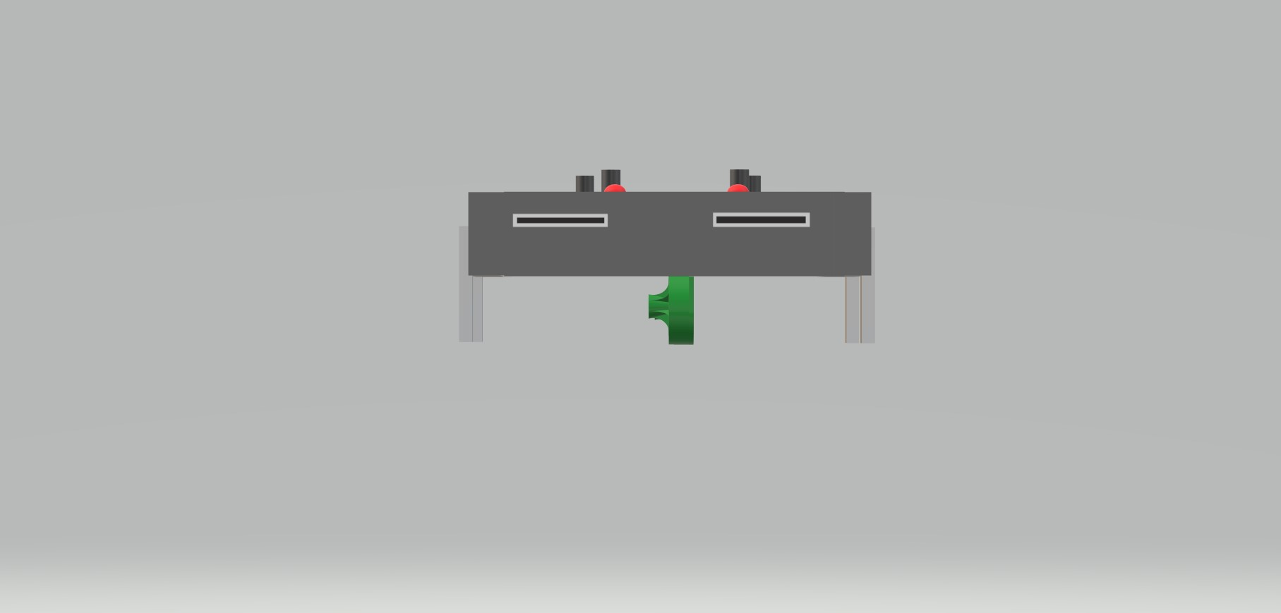
Top View


3D View
